**Selenium Locators Assignment:**

**Problem 1**- Open <https://www.phptravels.net/hotels> website and locate the following and Write xpath.

* PHPTRAVLES Logo

//div[contains(@class,'logo')]//img[@style='max-height:40px;border-radius:5px;background:transparent;padding:4px;']

* Home

//div[contains(@class,'main-menu-content')]//a[text()='Home']

* Flights

//div[contains(@class,'main-menu-content')]//a[text()='flights']

* Tours

//div[contains(@class,'main-menu-content')]//a[text()='Tours']

* Company

//li[contains(@class,'footm')]//a

* Signup Btn

//div[@class='header-right-action pt-1 pe-2 b2b_agents']//a[text()='Signup']

* Login Btn

//div[@class='header-right-action pt-1 pe-2 b2b_agents']//a[text()='Login']

* Agents DropDown

//div[@class='header-right-action pt-1 pe-2 b2b_agents']//button[@id='agents']

**Problem 2**- Write **Xpath** for Below Web elements using Xpath Axes (such as preceding, following, ancestor, following-sibling etc..)

* Check in - Calendar Icon
* Check Out – Calendar Icon
* “- ” for Adults
* “+” for Adults
* “-“ for Childs
* “+” for Childs

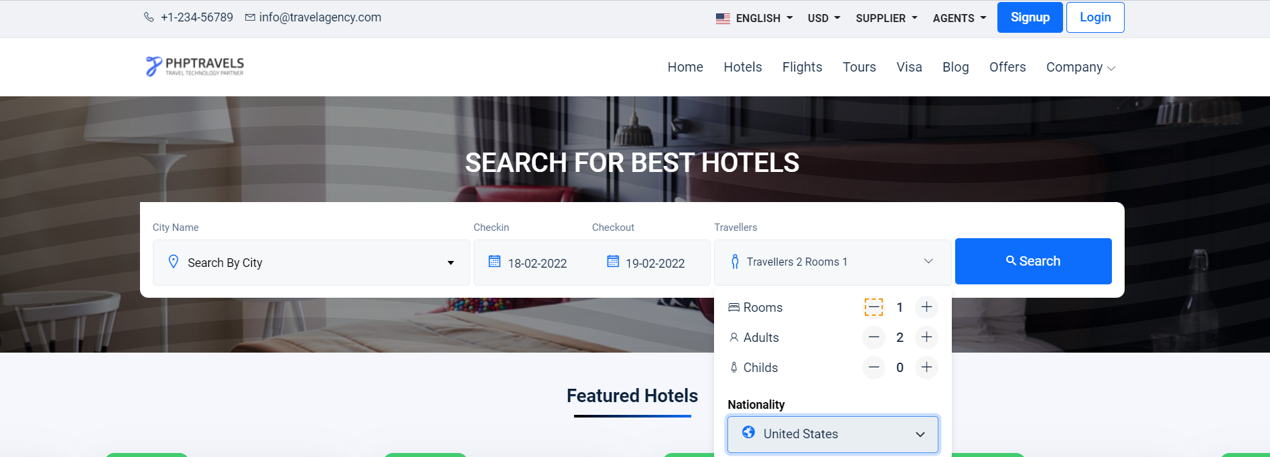

**Note : Don’t Use Indexes**